How to choose jewellery that truly delights
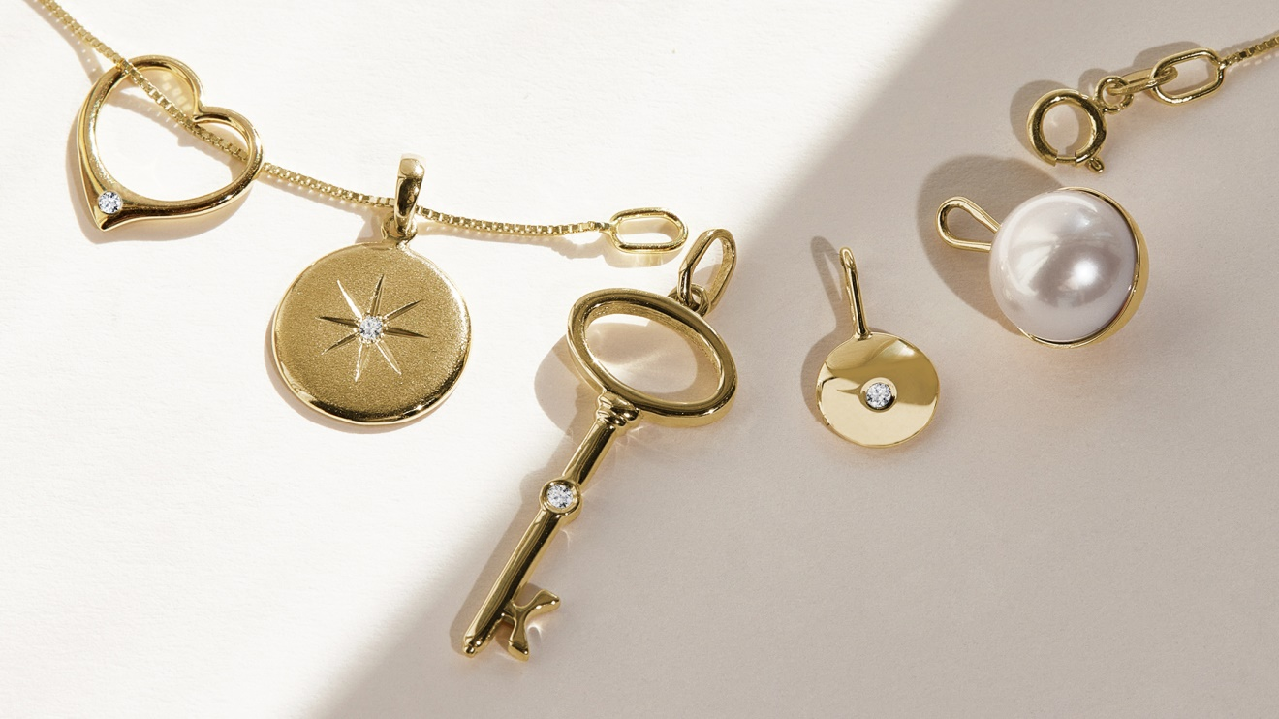
There are many moments throughout the year when you may want to show your love and appreciation to the women who play an important role in your life. Whether it’s your partner, mum, daughter, or sister you’d like to surprise, it pays to choose a gift with real meaning. Forget the clichés and opt for something that is not only beautiful but also personal. Minimal jewellery pieces can be dainty, yet they also convey strength – exactly the kind of quality reflected in the woman you are giving them to.

A pendant that highlights her personality
Understated yet enchanting – pendants can instantly attract attention. And there are endless possibilities: a shiny star, a romantic heart as a symbol of love or a timeless pearl that will never get old. Every woman will appreciate a piece of jewellery that captures her personality.

A necklace with a story
Choose a fine minimal design suitable for everyday wear or a striking piece that highlights her elegance and uniqueness. Layering different lengths and styles will add a touch of fair and something different to an outfit. If you want to tell a story with a necklace, pair a fine, understated chain with a pendant that symbolizes your love, friendship or the memorable moments you've shared together.

Hoop earrings–a classic that never gets old
Circles are a symbol of harmony and infinity, which may be the reason why hoops are so popular and timeless.Their clean, rounded shape flatters almost every face and works with an endless variety of outfits. Whether a woman prefers small, subtle hoops that hug the earlobe or larger designs studded with diamonds and gemstones, you simply can’t go wrong with this gift. Hoops are versatile, suit any occasion and never go out of style. They can be the finishing touch to an elegant evening gown, but they also look perfectly natural with jeans and a T-shirt. Modern variations include textured surfaces, unusual oval shapes, or hoops adorned with pearls, which give this classic piece a refreshing twist. If you want to make the look even more striking, pair hoops with an ear cuff or mix different sizes in one ear for a contemporary layered effect.

Minimal rings–small details with a big meaning
Rings have won the hearts of many women, and thanks to their versatility they offer countless styling options. They can be worn on their own as subtle accents, or stacked together to create a new and original look every time. Yellow or white gold? A combination of both? A band with a tiny diamond or a gemstone in her favourite colour? Or simply a plain, polished circle? The possibilities are endless. Thin rings are ideal for layering across multiple fingers, while slightly wider bands with unique details — such as chevron shapes or textured finishes — add character to the whole set. Beyond fashion, rings also carry symbolic value. A gift of a ring can represent love, friendship, or a promise. That’s why it is worth choosing durable materials such as gold or platinum, which not only ensure lasting beauty but also turn the piece into a meaningful keepsake.

Personalized jewellery–when you want to give a memento
Some gifts go far beyond beauty and become part of a person’s story. Personalised jewellery engraved with a name, date, or heartfelt message adds a layer of intimacy that makes it truly unforgettable. A necklace with initials, a bracelet with a meaningful date, or a pendant carrying a secret word known only to the two of you transforms a simple accessory into a treasured memento. Such jewellery is not just an ornament but a constant reminder of love, family, or a special milestone. Because of this, personalised pieces are often passed down from generation to generation, carrying memories with them. Choosing such a gift shows thoughtfulness and care, proving that you selected it with your heart first and foremost.

How to choose the right jewellery
Think carefully about what would genuinely bring a smile to your loved one’s face. Does she prefer understated elegance, or does she enjoy bold, eye-catching jewellery? Look at her favourite colours, the clothes she wears most often, and the styles she gravitates towards. A woman who dresses in minimal lines may appreciate clean, subtle designs, while someone with a more expressive fashion sense might love statement pieces. Don’t forget that the presentation is part of the experience. A beautifully wrapped gift box tied with a ribbon, accompanied by a personal note, can turn even a simple piece of jewellery into an unforgettable moment. The thought and effort you put into both the choice and the presentation will be felt every time she wears it.

